R. Reports Menu: 3. Check Warrant

Table of Contents
Check Warrant 3
The “Options” tab 3
The “Warrant Bottom” tab 5

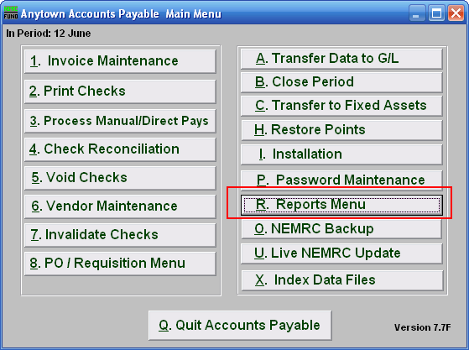
Click on “R. Reports Menu” from the Main Menu and the following window will appear:

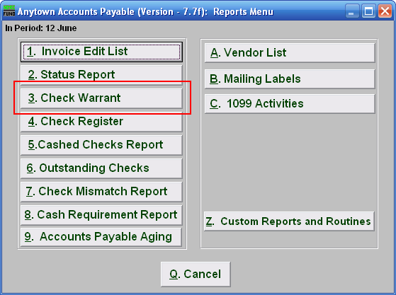
Click on “3. Check Warrant” from the Reports Menu and the following window will appear:

Check Warrant

The “Options” tab

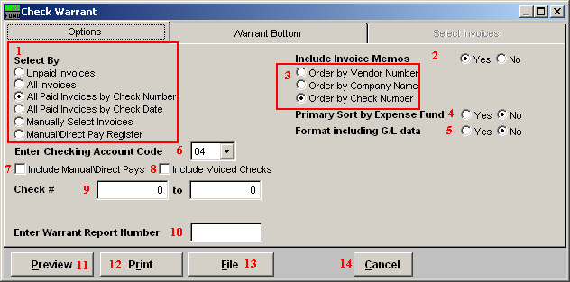
- Select By: Choose what you want to create a Check Warrant report for.

- Include Invoice Memos: Choose whether or not you want to have the Memos for each Invoice to appear on the report.

- Order by: Choose what you want this report to print in order of.

- Primary Sort by Expense Fund: The report will group all reference accounts associated by the expense fund before the option 3 choice when this option is set to yes.

- Format including G/L data: Each reference account and description will appear related to each invoice paid on the report when this option is set to yes.

- Enter Checking Account Code: Enter the checking account code or select from the drop down menu. Checking account codes are set up in installation.

- Include Manual/Direct Pays: Check this box to include Manual and Direct Pays in this report.

- Include Voided Checks: Check this box to include Checks that have been Voided in this report.

- Check #: Enter a Check number range for this report. If you select the option of “All paid invoices by check date” then the check date range will appear here.

- Enter Warrant Report Number: Enter the warrant number to print on the report if you assign them

- Preview: Click this button to preview. Refer to GENERAL PREVIEW for more information.

- Print: Click this button to print. Refer to GENERAL PRINTING for more information.

- File: Click this button to save on this computer. Refer to GENERAL FILE for more information.

- Cancel: Click “Cancel” to cancel and return to the previous screen.

The “Warrant Bottom” tab

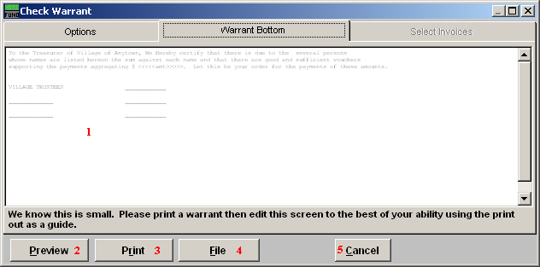
- Edit: You should print this check warrant, and then edit this screen as best you can. Print again and review after you make changes. Some users place each board members name under a specific line for their respective signature.

- Preview: Click this button to preview. Refer to GENERAL PREVIEW for more information.

- Print: Click this button to print. Refer to GENERAL PRINTING for more information.

- File: Click this button to save on this computer. Refer to GENERAL FILE for more information.

- Cancel: Click “Cancel” to cancel and return to the previous screen.

